**Project Name** : A web based project on **RUET CSE Alumni**.

**Introduction :**

The RUET CSE ALUMNI ASSOCIATION (RUETCSEAA) is an association of CSE graduates of Rajshahi University of Engineering and Technology. The organization seeks to promote fellowship among CSE graduates, to assist members to develop careers that use their abilities and education, and to maintain a database of skills that can be furnished to domestic and international users. The project is made to provide the cseians of RUET a platform to interact with each other for their educational and personal needs. The website provides all the information about the RUETCSEAA.

**Features :**

1. There are only past and present CSE students of RUET.

2. Every member will have his/her own account.

3. Every member can know the contacts of other including their professions, positions, academic activities but only if the user allows.

4. There will be information about recent activities.

5. All updates related to the university especially to the CSE department.

6. All information about CSE department i.e. office, professors etc.

7. Any kind of news will be delivered to all members if they want to.

8. There will be chance to give any solution that can make the CSE department more prestigious and successful.

There will be other services for which user can remain in touch with the CSE department, seniors and juniors from anywhere.

**Tools :**

1. HTML

2. CSS

3. PHP

4. JAVASCRIPT

5. DATABASE

**Website Description :**

**1. Home :**

The fig-1 shows the home page of the website. It contains a short summary of all features of the RUETCSEAA.

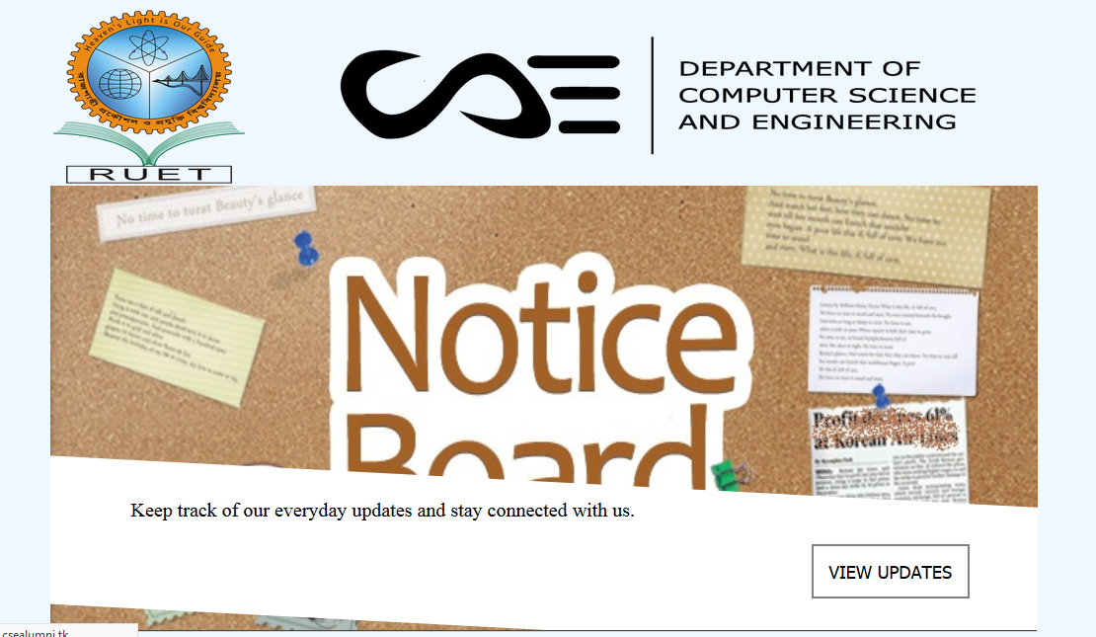

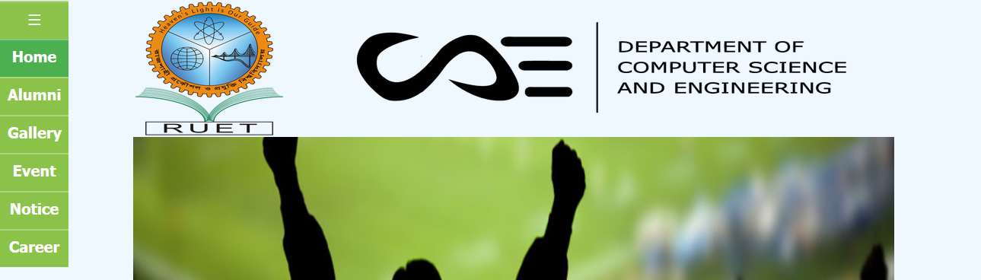

fig-1

The second picture shows the menubar of the website which is in the top left corner of the website. One can make hidden/visible the menubar.

**2. Active Account:**

To start the journey in the RUETCSEAA website one needs to active his/her account.

To active an account follow the following steps:

step-1 : Click on the "ACTIVE YOUR ACCOUNT" button

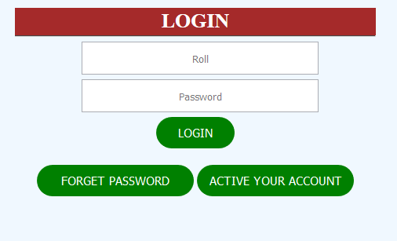

step-2 : Insert roll to get a security code to the email account given at the time of admission and click "SUBMIT"

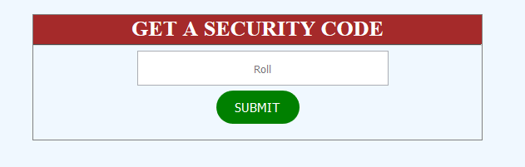

step-3 : Set password using the security code given to the email account

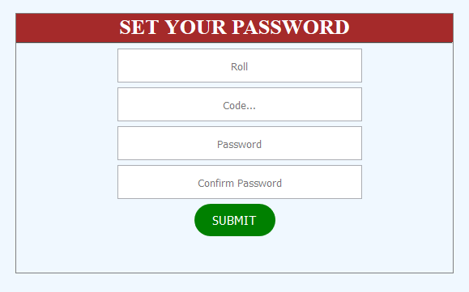

The account activation is complete.

**3. Login :**

To login to the account complete the following form and press "LOGIN"



**4. Password Recovery :**

If someone forgets his/her password he/she needs to follow the steps of 'Active Account'.

**5. Alumni :**

To view the member list one can press "Alumni" in the menu.

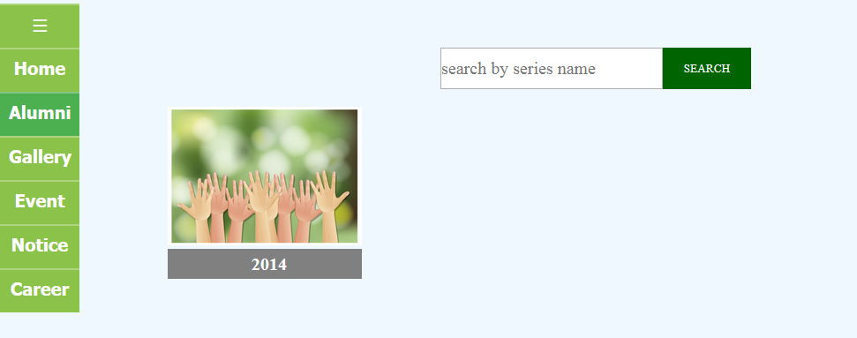

Alumni member list series by series

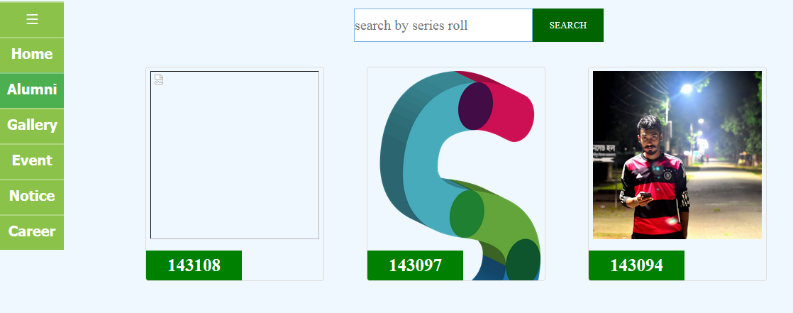

Alumni member list of a particular series

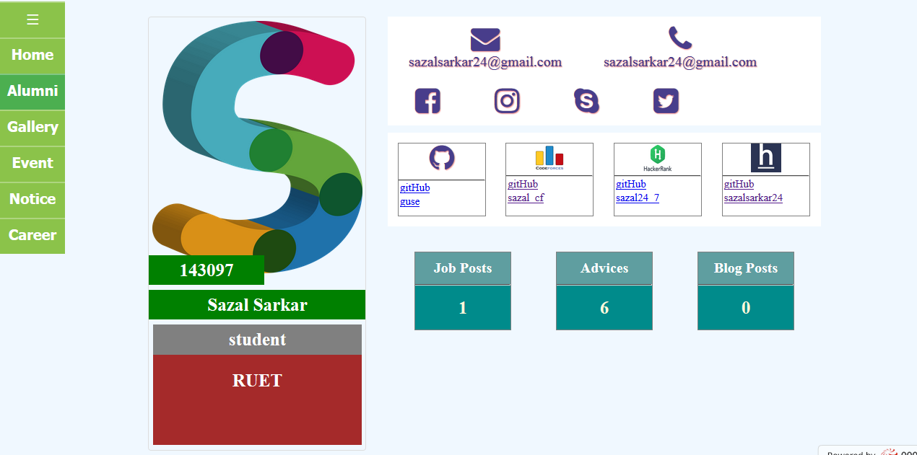

An user profile(Without Login)

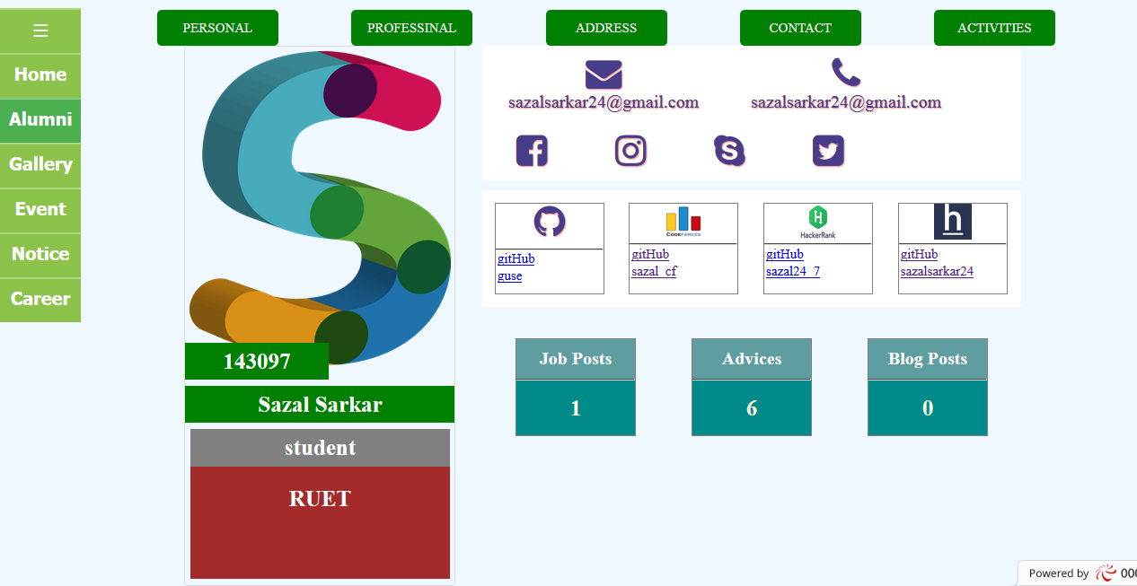

An user profile (When logged in)

**6. Gallery:**

There is a gallery section in the website which contains the memorable moments of the RUETCSEAA.

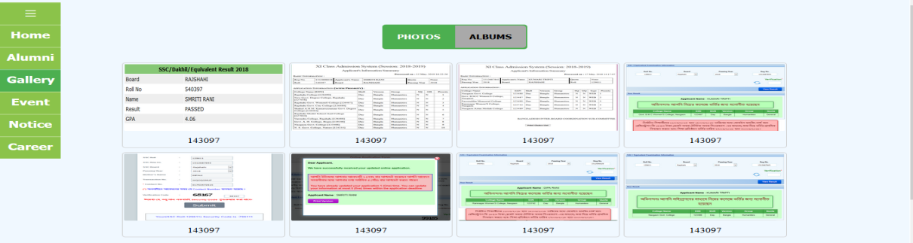

gallery

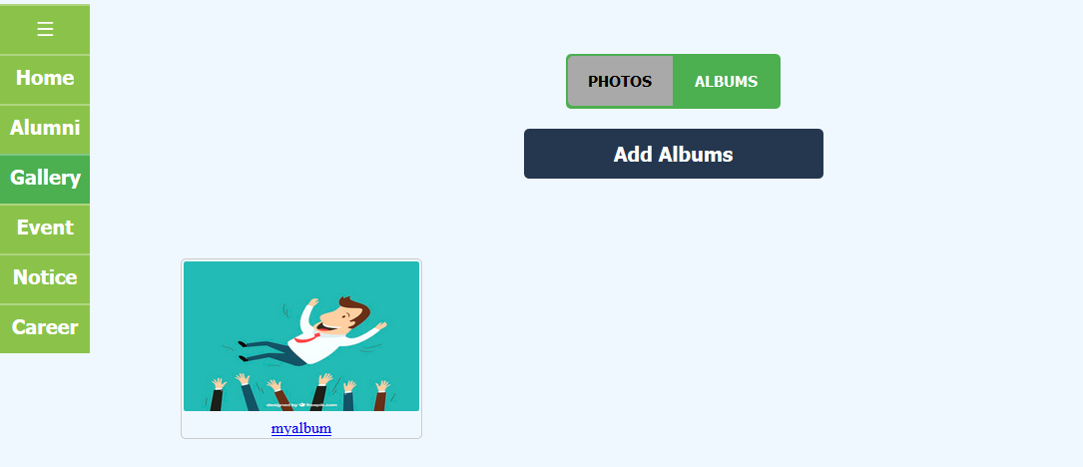

Album list

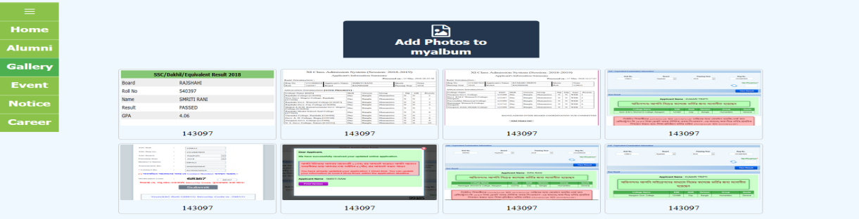

A full album

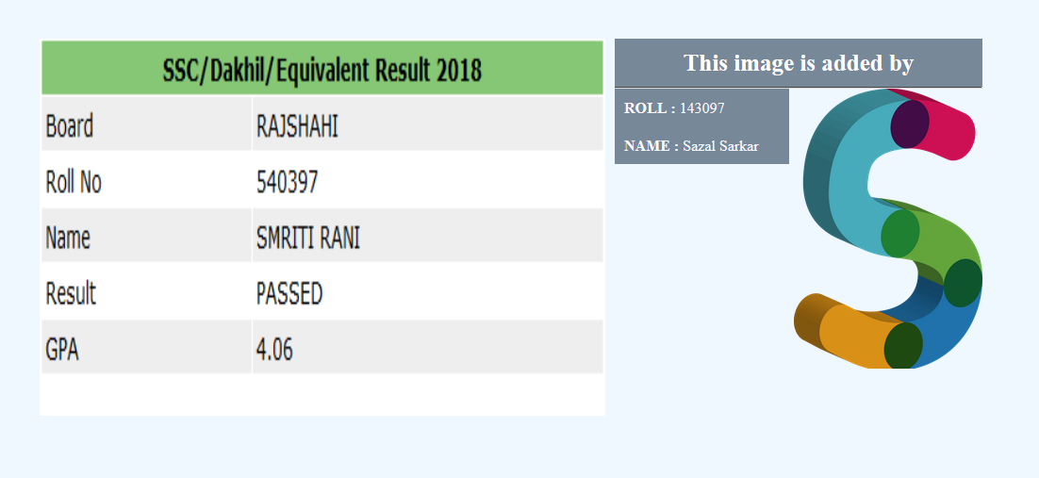

A photo added by a member

One can add an album or add a photo to a particular album, but he/she needs to a member of the alumni.

**7. Event:**

The RUETCSEAA arranges a lot of events. The event section of the website contains the details of all upcoming, ongoing and past events.

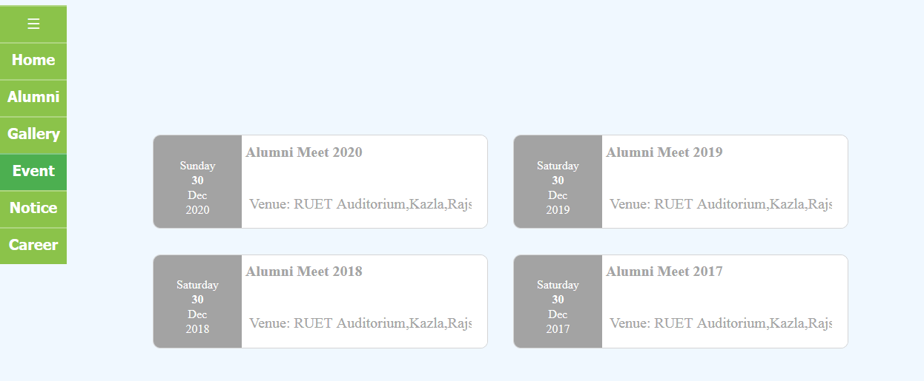

Event list

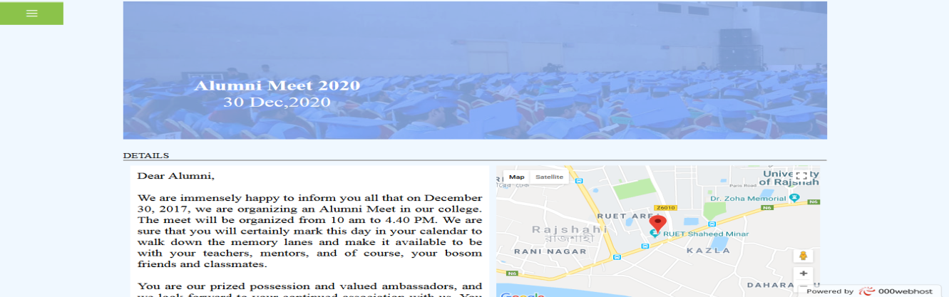

An event with all details

**8. Notice:**

This section of the website contains the notice board.

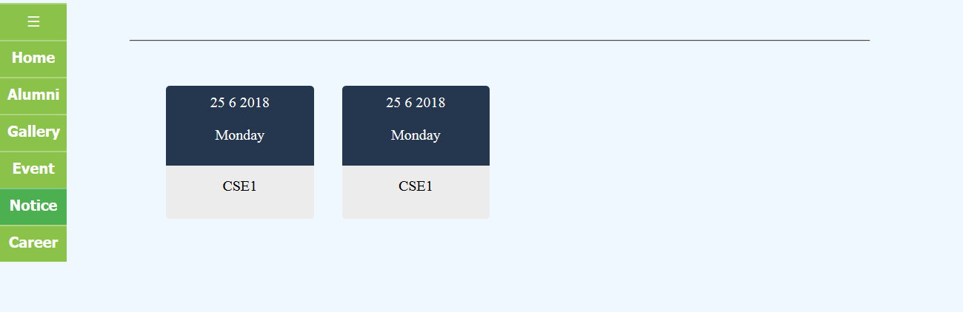

Notice list

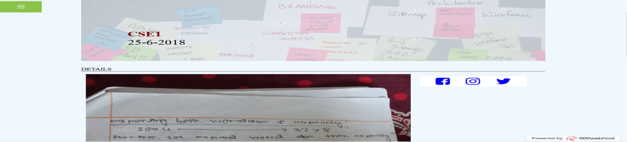

Full notice with all details

**9. Career:**

This section of the website contains all career advices and opportunities provided by the members of the RUETCSEAA.

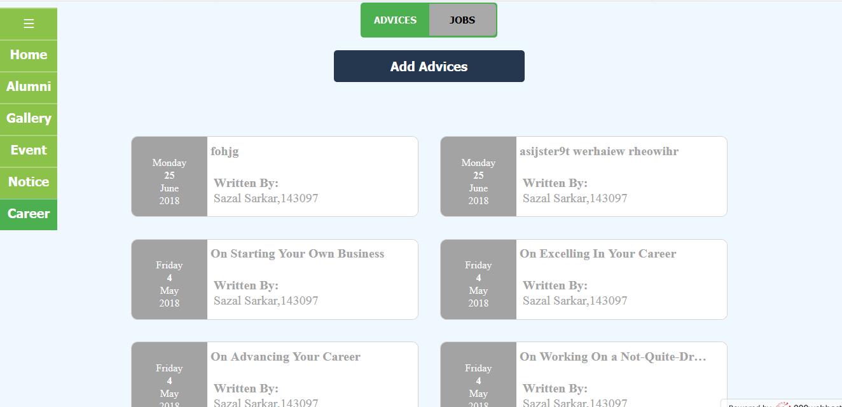

List of career advices

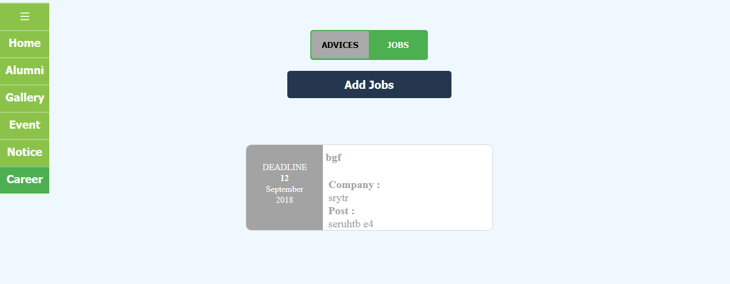

List of available opportunities

**10. Contact:**

One can send a message and contact with us using this portion of the website.

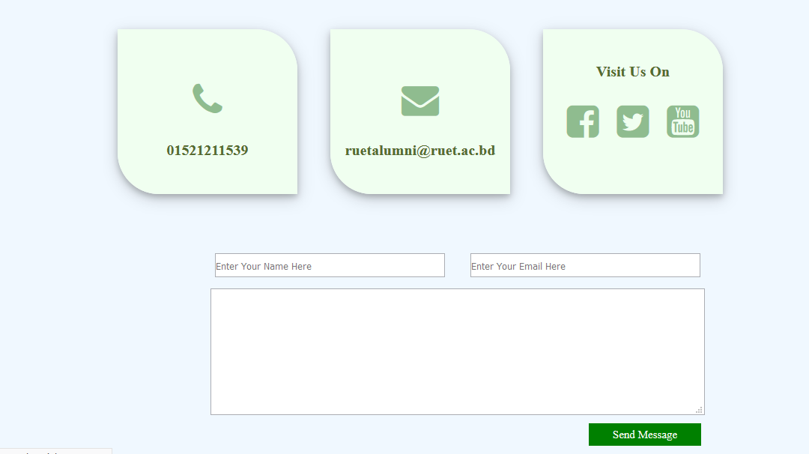

Contact form

**11. We and Our location:**

This section of the website shows the location in map and the details of the RUETCSEAA.

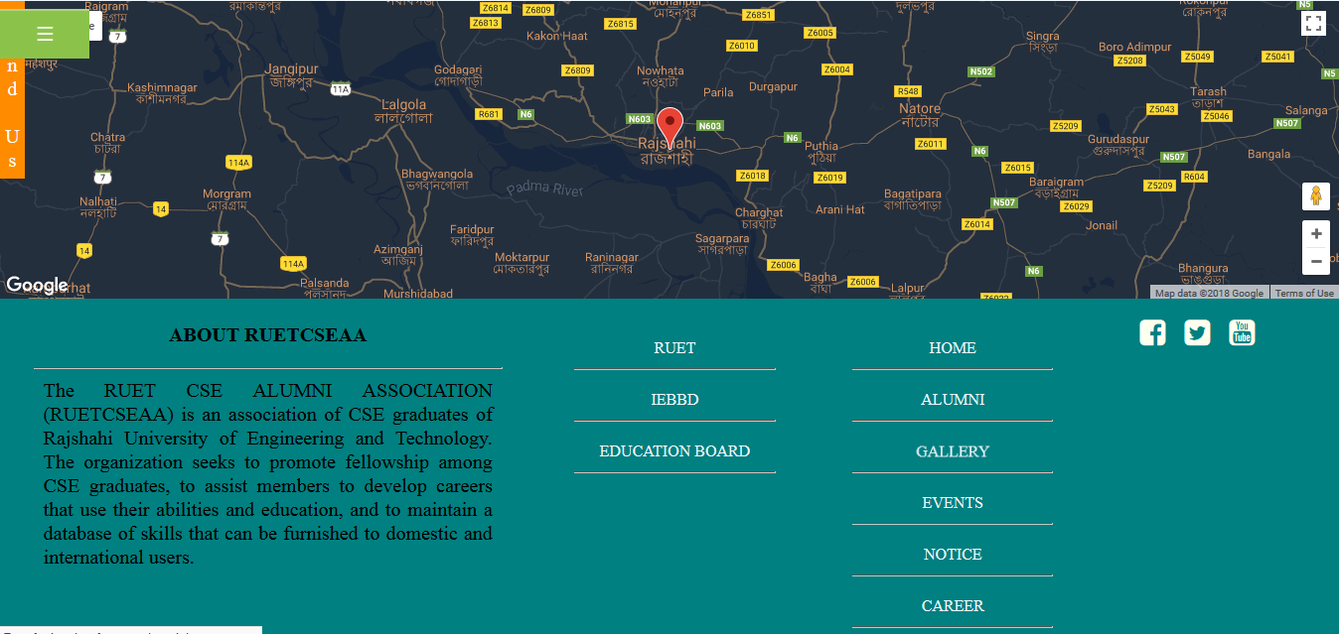

**Conclusion :**

The whole website contains the full information of RUETCSEAA services and objects. Through this website the RUETCSEAA makes an area in which the members can communicate with other to improve their skills and lighten the name of the department of CSE RUET. This website is also a news teller to the non-members who can see how well and how designed the RUET CSE is.